**IOT BASED SMART WATER MANAGEMENT**

**A project report submitted in partial fulfillment of the requirements for the degree of B.E- Computer Science and Engineering**

**By,**

**J.Shyam sundhar(513221104024)**

**Under the supervision of professor & HOD Department of B.E- Computer Science and Engineering**

**SMART WATER MANAGEMENT**

**PHASE -1 PROBLEM DEFINITION AND DESIGN THINKING**

**Problem statement**

**Design thinking approachProblem statement:**

Purpose: Worldwide water scarcity is one of the major problems to deal with. Smart Cities also faces this challenging problem due to its ever-increasing population and limited sources of natural water. Additionally, careless usage of water and large water wastage has made the water issues as a serious concern. Today Smart Cities are using advanced...

Worldwide water scarcity is one of the major problems to deal with. Smart Cities also faces this challenging problem due to its ever-increasing population and limited sources of natural water. Additionally, careless usage of water and large water wastage has made the water issues as a serious concern. Today Smart Cities are using advanced technical...

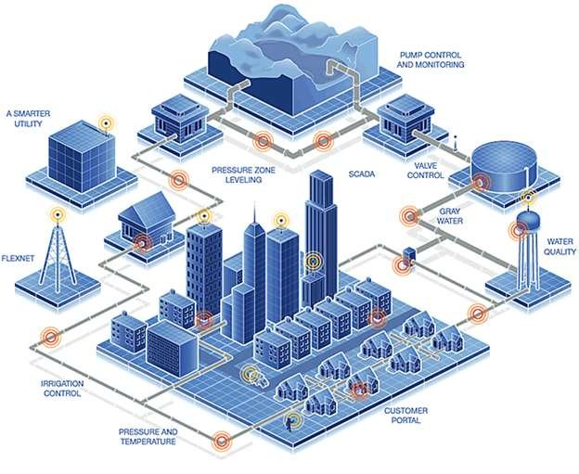

The concept of “water smart city” is increasingly being recognized as a new approach to managing urban environments (including urban floods), especially in the context of developing countries, such as Indonesia. While Indonesia’s national capital relocation plan is expected to attract significant human migration to two nearby

**CHALLENGES IN SMART WATER METERING**

Although there are many benefits and opportunities the smart metering delivers, the adoption is very slow due to high costs, technology limitations, regulatory frameworks, and others.

Major drawbacks include;

* High deployment and maintenance costs
* Lack of sufficient infrastructure to support smart metering
* Lack of skills
* Interoperability issues
* Weak communication signals in some locations
* Power cabling challenges in confined and remote locations

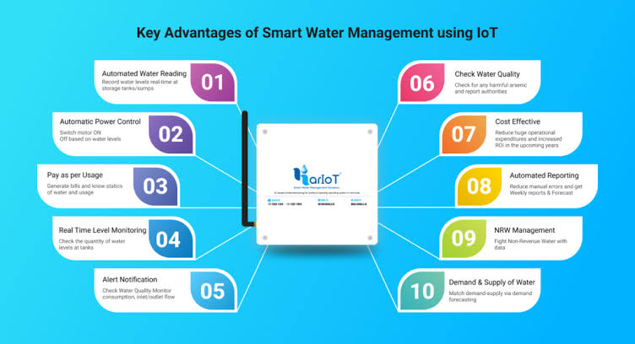

Smart water metering (SWM) system relies on several technologies to automate the collection and analysis of meter data. A typical system comprises a water meter with a data logger to capture the information, a communications technology to transmit the captured data, and a server to process the information.

Usually, the smart system enables utilities or third-party companies to continuously monitor or read the water usage information in real-time or at set intervals. It also allows customers to access their consumption data from the online portals – using mobile devices and computers.

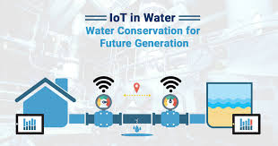

## BENEFITS OF SWM

Smart metering improves the operations while reducing the consumption per capita, wastage, leakages, and operational and maintenance costs. Major benefits include;

* Monitor the flow, distribution, and consumption of water
* Improve access to clean and safe water
* Enable real-time or frequent access to water consumption information and billing
* Reduce manual water meter reading and cost
* Improve leak and fraud detection
* increases data collection accuracy

Design Thinking Approach:

This is where the problem arises. The pump is usually operated manually using a switch. The pump is turned on to fill the tank when the residents discover a thinning tap and this can happen without warning. There have been many instances of this happening in the middle of me taking a shower and it’s frustrating. An even bigger problem is when someone forgets to switch the pump off and water starts overflowing from the overhead tank. This was a regular occurrence in my neighborhood. The system was simply not designed to make the experience comfortable for its users. People were not given sufficient feedback about the situation and they had to suffer in the form of paying excess water bills or staring at empty taps when they really needed water. 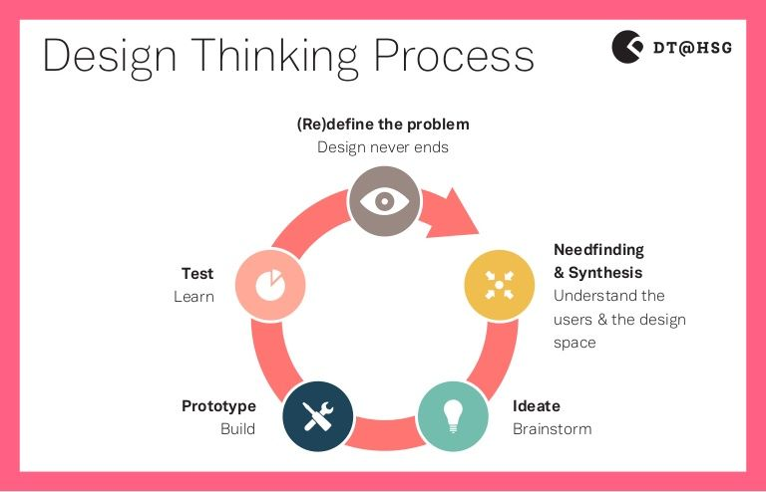

**The aim of our project was not to merely find ways to connect the process of pumping water to a mobile app, rather to explore ways to make the entire system smarter by leveraging technology.**While we couldn't address every single touch-point involved in the process, we addressed the 3 most important concerns raised by the people we spoke to -

1. Knowing current water level in the tanks without having to find an empty tap or running outside.

2. Knowing when the next government water supply is & other critical water related information.

3. Being able to turn the pump on/off remotely and when needed without worrying about the tank overflowing.



**Key Advantages of IoT (Internet of Things) Water Management Systems**

Water scarcity will directly affect nearly 20% of the human population by 2025, according to several UN reports, and indirectly influence the rest of the planet’s inhabitants as well as economies and the whole ecosystems.

Smart water systems based on the combination of Internet of Things, big data and AI technologies can help stop these predictions from happening and undo the damage the imprudent usage of water resources has already caused.



**THANKING YOU**